**CalHIVE Behavioral Health Integration (BHI)**

**BHI Sustainability Plan – Section 1: Billing & Financing**

|  |  |
| --- | --- |
| **Team Name:** |  |
| **Date Updated:** |  |
| **Version:** | Version 1.1, revised 7/7/25 |

* Section 1 due by Tuesday, September 30 to your Improvement Advisor
* Section 2 due by Friday, October 31 to your Improvement Advisor
* Section 3 due by Friday, December 19 to your Improvement Advisor

**About the BHI Sustainability Plan**

* The **Sustainability Plan** is designed to support CalHIVE BHI organizations in planning for the long-term success of their behavioral health integration (BHI) programs—beyond pilot implementation and CalHIVE BHI funding.
* While the **Implementation Plan** focused on launching BHI at a pilot site—establishing workflows, staffing, training, and billing foundations—the Sustainability Plan builds on that work to address what comes next.
* This plan helps teams assess and strengthen:
  + **Billing and Financing Systems** (Section 1) to support ongoing reimbursement
  + **Culture and Engagement** (Section 2) to ensure staff and provider engagement in BHI
  + **Monitoring and Playbook** (Section 3) to ensure BHI can be maintained and expanded
* The Sustainability Plan is structured in sections, aligned with key technical assistance topics (billing, culture, monitoring/playbook), and includes a flexible “menu of improvement actions” for teams to select from based on their context and readiness.
* By completing the Sustainability Plan, organizations will be better equipped to maintain integrated care as part of their standard operations and make the case for continued investment in behavioral health.
* Completion of these 3 documents will demonstrate fulfillment of Program Year 3 payment deliverables.

**Instructions**

* As part of CalHIVE BHI, each team will complete a **Behavioral Health Integration Sustainability Plan**, which supports long-term planning for sustaining and expanding integrated behavioral health services.
* This plan builds on the foundational work completed in the Implementation Plan and focuses on the next phase: strengthening billing and financing, embedding BHI into organizational culture and creating infrastructure for monitoring and spread.
* Teams are encouraged to complete the Sustainability Plan collaboratively—during Improvement Advising sessions or in internal meetings—and select relevant improvement actions from each section’s menu to create a tailored workplan.
* Note: The Sustainability Plan will include three sections and an action plan, each of which will be due at different times with different focus areas.
  + Action Plan steps DO NOT need to be completed by time of submission.

**Sustainability Plan: Section 1: Billing & Financing**

Objective: Strengthen the financial sustainability of the BHI program through improved billing workflows, documentation and financial tracking.

CalHIVE BHI Work supporting Billing & Financing:

* Section 5 Implementation Plan – BHI Billing and Coding
* Financial Pilot Measure (via Tableau dashboard)
* Data Packet (May 2025 CalHIVE BHI Convening)
* SWOT Analysis (May 2025 CalHIVE BHI Convening)
* [November 2023 Commons Webinar](https://www.calquality.org/calhive-bhi/#:~:text=Tuesday%2C%20November%2014%20%E2%80%93%20BHI%20Billing%20and%20Coding%20Slide%20deck%3B%20Webinar%20recording) – BHI Billing and Coding
* February 2024 BeeHIVE Webinar – Billing and Coding Office Hours
* [October 2024 Commons Webinar](https://www.calquality.org/calhive-bhi/#:~:text=Tuesday%2C%20October%208%20(11%2D12pm)%20%E2%80%93%20BHI%20Revenue%20Cycle%20Successful%20Practices) – BHI Revenue Cycle Successful Practices
* [CA Billing and Payment Codes](https://www.calquality.org/wp-content/uploads/2025/08/CQC_Billing-and-Payment-Codes_CA_2025_Final.pdf) (revised July 2025)

**Improvement Actions**

*Teams are expected to complete all Core Actions and select at least three Improvement Actions from a minimum of two different categories*

| **Improvement Area** | **Action #** | **Action** | **Description** | **Recommended For:** |
| --- | --- | --- | --- | --- |
|  |  | **Core Actions** – All required |  |  |
| **Billing Practices** | 1.1 | Identify and consistently bill for appropriate BHI billing codes (e.g., 90832, 99484, 99492) (refer to [CA Billing and Payment Codes sheet](https://www.calquality.org/wp-content/uploads/2024/02/CalHIVE-BHI_Billing-and-Payment-Codes_CA_2024.pdf)) | Ensure accurate coding and alignment with payer requirements, including an annual update process for relevant codes | All sites |
| **Billing Practices** | 1.2 | Review and update documentation templates in EHR. Add smart/dot phrases in EHR ([PCBH/CoCM Template Note)](https://www.calquality.org/calhive-bhi/#:~:text=PCBH/CoCM%20Template%20Note%20with%20Drop%20Downs) | Ensure templates support compliant and billable documentation | All sites |
| **Financial Review** | 1.3 | Conduct at least one review of claim denials and create a regular schedule for claims denial review | Identify trends and inform resolution processes | All sites |
| **Financial Review** | 1.4 | Complete a basic ROI (sample template below) or break-even analysis, consider including indirect costs (facility fees/ indirect) associated with the BHI program | Estimate sustainability and inform future planning | All sites |
| **Innovation & Planning** | 1.5 | Identify ROI findings to share with leadership. | Schedule and plan for a meeting (Section 2 requirement) with leadership to share ROI findings and align for long-term sustainability | All sites |
| **Staff Engagement** | 1.6 | Identify finance/billing point of contact for regular check-ins with clinical team or available as needed to ensure shared financial measures of success, e.g. CalHIVE BHI Financial Measure | Create a bi-directional communication loop on documentation standards, coding errors and claim status, ensuring real-time updates and actionable feedback with leads across departments | All sites |
|  |  | **Improvement Actions –** Select minimum 3 items from at least 2 different areas |  |  |
| **Revenue Cycle Management** | 2.1 | Implement a billing submission checklist | Ensure documentation accuracy before submission | All sites |
| **Revenue Cycle Management** | 2.2 | Build a dashboard for billing and revenue KPIs | Visualize and analyze financial performance | Sites with analytics capacity |
|  |  |  |  |  |
| **Documentation & Coding** | 3.1 | Train providers on billing-relevant documentation | Targeted training to increase reimbursement success | Site with varied provider engagement |
| **Documentation & Coding** | 3.2 | Create audit tool and process for BHI notes and regularly audit for billing readiness | Check if documentation meets standards | All sites |
|  |  |  |  |  |
| **Contracting & Credentialing** | 4.1 | Audit credentialing status for BHI staff | Ensure all eligible staff are credentialed | Sites scaling or hiring |
| **Contracting & Credentialing** | 4.2 | Create a payer matrix | Track accepted codes and restrictions by payer, including rates per codes and percentage of patients per payer | Sites with many contracts |
| **Contracting & Credentialing** | 4.3 | Include BHI strategy in meeting with at least one payer | Advocate for improved contract/billing arrangements supporting BHI. Recommended to have an annual routine request for rate increase | Advanced sites |
|  |  |  |  |  |
| **Cross-Team Communication** | 5.1 | Host billing training across teams, reflective of different roles | Improve understanding of roles and expectations | Sites with workflow misalignments |
| **Cross-Team Communication** | 5.2 | Designate an operational/administrative BHI billing lead | Point person for issue escalation | All sites |
|  |  |  |  |  |
| **Innovation & Planning** | 6.1 | Forecast revenue under different staffing models | Evaluate investment strategies | Sites exploring expansion |
| **Innovation & Planning** | 6.2 | Evaluate potential for alternative payment methods (i.e.: grants, external funding sources) | Align with state and federal trends | Financially strategic teams |
| **Innovation & Planning** | 6.3 | Explore expanded billing aligned with BHI workflows (e.g., eConsult, peers/ CHWs) | Identify future reimbursable services | Site using paraprofessionals |
|  |  |  |  |  |

**Team Selection and Workplan**

***Complete the table below as part of your plan.***

* *ALL Core Actions must be completed.*
* *Select at least 3 Improvement Actions from at least 2 different Improvement Areas. Additional Improvement Actions may be selected, if desired.*
* *All actions DO NOT need to be completed by submission date.*

|  |  |  |  |  |  |
| --- | --- | --- | --- | --- | --- |
| **Action #** | **Selected Action** | **Workplan** | **Planned Completion Date** | **Team Lead** | **Supporting Documentation  (add relevant sources)** |
| 1.1 | Identify and consistently bill for appropriate BHI billing codes (e.g., 90832, 99484, 99492) (refer to [CA Billing and Payment Codes sheet](https://www.calquality.org/wp-content/uploads/2024/02/CalHIVE-BHI_Billing-and-Payment-Codes_CA_2024.pdf)) |  |  |  |  |
| 1.2 | Review and update documentation templates in EHR. Add smart/dot phrases in EHR ([PCBH/CoCM Template Note)](https://www.calquality.org/calhive-bhi/#:~:text=PCBH/CoCM%20Template%20Note%20with%20Drop%20Downs) |  |  |  |  |
| 1.3 | Conduct at least one review of claim denials and create a regular schedule for claims denial review |  |  |  |  |
| 1.4 | Complete a basic ROI (sample template below) or break-even analysis, consider including indirect costs (facility fees/ indirect) associated with the BHI program |  |  |  |  |
| 1.5 | Identify ROI findings to share with leadership. |  |  |  |  |
| 1.6 | Identify finance/billing point of contact for regular check-ins with clinical team or available as needed to ensure shared financial measures of success, e.g. CalHIVE BHI Financial Measure |  |  |  |  |
|  |  |  |  |  |  |
|  |  |  |  |  |  |
|  |  |  |  |  |  |

**Appendix:**

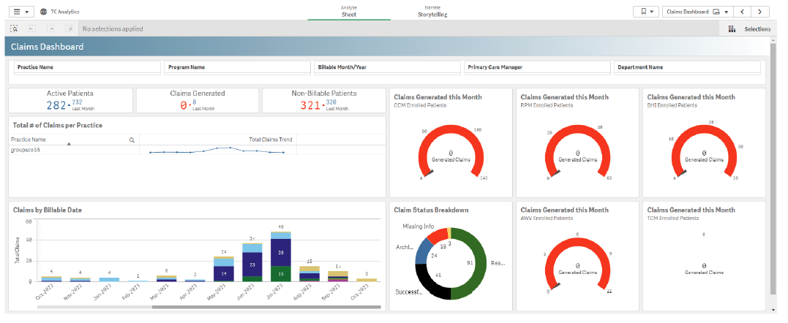Example of KPI Dashboard

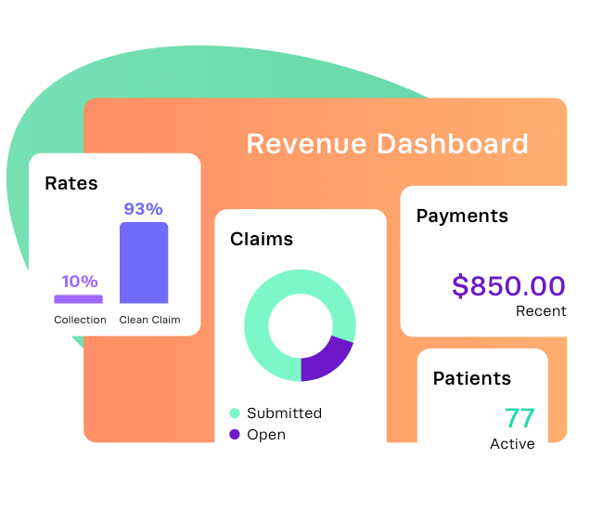

**Direct ROI $ Worksheet**

1. Role/Process:
2. Annual gain/income from individual/process (follow steps to calculate below)
   1. Billable patients/services each day:
   2. Daily revenue (calculate below)

|  |  |  |  |
| --- | --- | --- | --- |
| **Service codes** | **Revenue per code** | **# Patients/services per code** | **Total** |
|  |  |  |  |
|  |  |  |  |
|  |  |  |  |
|  |  |  |  |
|  |  |  |  |

**Total daily revenue/gain = $**

* 1. Monthly revenue (calculate below)

**# Days per month BHI provider works x Total daily revenue/gain = $**

* 1. Annual revenue (calculate below)

**Total monthly revenue x 12 = $**

1. Costs (provider annual compensation and benefits, facility/indirect): **$**
2. Calculate direct ROI $ (use formula below)

|  |  |
| --- | --- |
| **gain from individual/process – cost of individual/process** | **X 100 = % of ROI** |
| **cost of individual/process** |

**$ - $ X 100 = % of ROI**

**$**

1. Review results and evaluate:

*When identifying indirect costs, consider other similar programs