Organization: ____________________________

- Draft Aim Statement
As a reminder, here are characteristics of a good Aim:
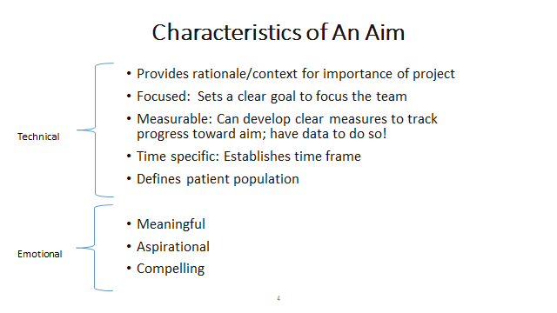
Step 1: Take a look at your baseline data and select measures for you Aim statement that:
- Align with organization’s strategic goals, value based programs
- Address areas to improve and that you can measure
- Impact large populations and/or have significant impact on morbidity, mortality, costs
- Are meaningful to patients and clinicians

Your Aim Statement:

- Selecting measures
Measure | Measure Type  Outcome, Process or Balancing | Description/Specs  (include numerator and denominator specs) | Number of Patients in the Denominator | Number of Patients in the Numerator | Baseline Rate | Target Rate | Number of Patients or Units to reach target | Reporting frequency


My Notes:

III. Selecting Target Practices
Selecting Target Population of Practices - Based on measures selected for improvement, please identify the practices you need to engage to reach your organization’s improvement goals.
What data can we use now?

What additional data do we need to identify potential sites?

Who will collect the data or conduct the analysis?

IV. Selecting First Set of Changes
Step 1: Are you ready to work with practices now?
Considering the discussion, are you ready to get started testing changes with practices in the next month?
If no, what steps should your organization take to get ready to work with practices?
Step 2: Considering the discussion, which changes would you like to try first, or learn more about?
Measure(s) | Change to explore or test | Who needs to be involved?  (specific people)

V. Creating Small Tests of Change
Choosing one or two ideas to test from page 4, plan your first PDSAs:

PLAN:
Briefly describe the test:

How will you know that the change is an improvement?

What do you predict will happen?

PLAN
List the tasks necessary to complete this test (what) | Person responsible (who) | When | Where
1.

2.

3.

4.

5.

6.

Plan for collection of data:

PDSA #2
PLAN:
Briefly describe the test:

How will you know that the change is an improvement?

What do you predict will happen?

PLAN
List the tasks necessary to complete this test (what) | Person responsible (who) | When | Where
1.

2.

3.

4.

5.

6.

Plan for collection of data:

VI. Most important things to do when we go home
_____Does your team have a regular time to meet?
_____Do you have everyone on the team you need?
_____Is there anything you need to review with senior leaders?

List of Next Things to Do When We Get Home:

My Notes:

